VIVALDI BROWSER LOCATION TROUBLESHOOTING FIX
The Kin Club of Russell is mandated by the Alcohol & Gaming Commission of Ontario (AGCO) as part of our Catch the Ace 6 lottery (RAF1341100), to utilize a location software to prevent anyone physically outside of the province of Ontario from purchasing online tickets.
The issue you may be having in trying to purchase tickets, is not with our system, but rather your personal browser settings blocking access to show its location. If your browser refuses to show its actual location, tickets sales will be refused as it cannot verify you are physically in the province. Please note this is your browser settings and not your general notification settings.
Please follow the following steps;
- If you are using a Virtual Private Network (VPN), please turn it off to purchase your tickets.
- Open the Kin Club of Russell’s Catch the Ace page on your device – www.kinclubofrussell.ca/catch-the-ace/
- If you see the screen below, your settings are blocking access to our website for purchases.

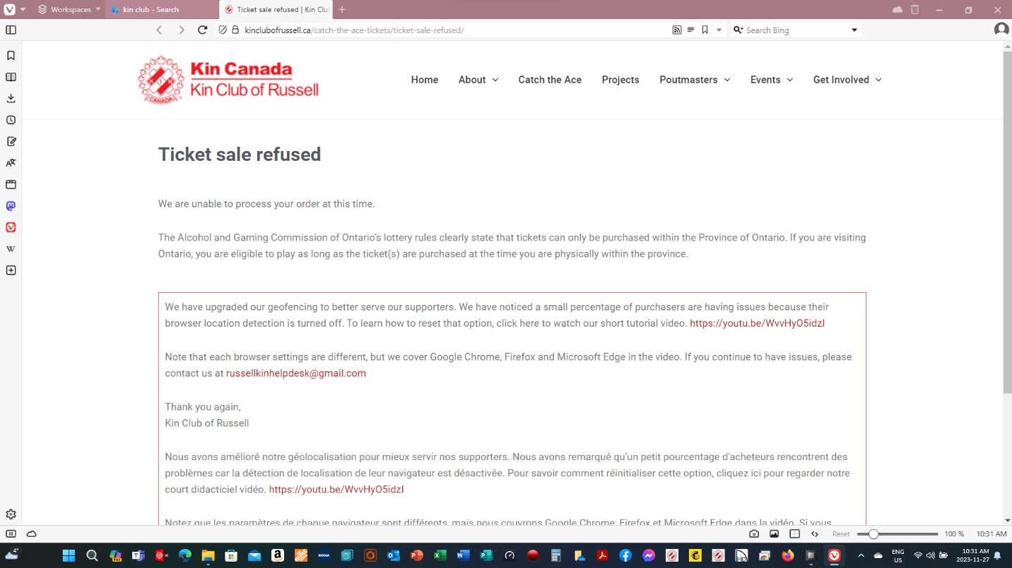

- Slide the Location “slide” to the right as shown below. The slide will turn blue to show it is now open to location settings.
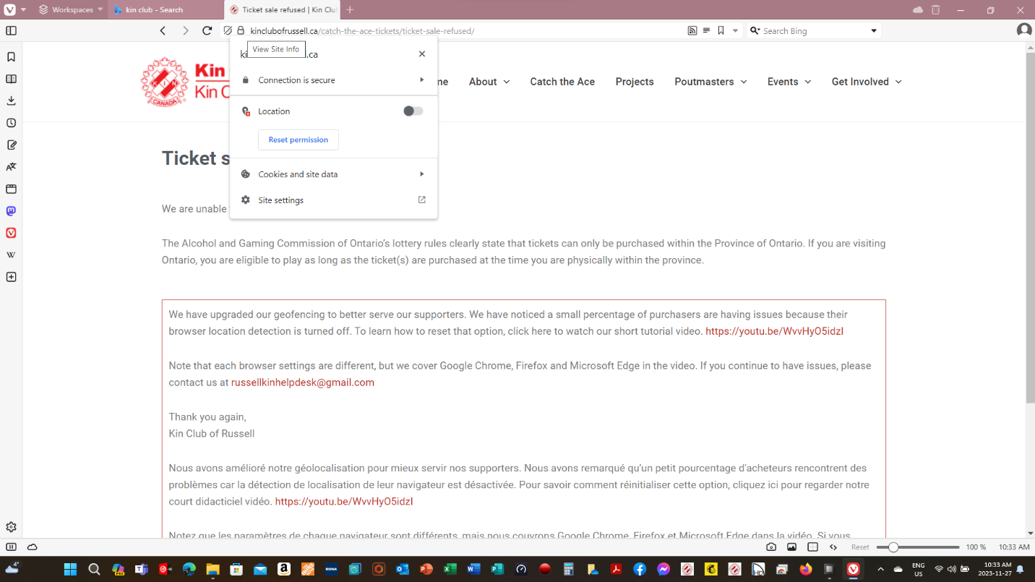

- Close your page/tab completely. Re-open your page at www.kinclubofrussell.ca/catch-the-ace/
- You should be able to purchase your tickets.
- If you are still having troubles, other options include trying a different device or different browser.
- Contact the russellkinhelpdesk@gmail.com with the Subject Line “Need Help” and your phone number. We will call you promptly to help you purchase tickets online.
Thank you for your support of our charities and your understanding.

Kin Club of Russell

