SAFARI BROWSER LOCATION TROUBLESHOOTING FIX
The Kin Club of Russell is mandated by the Alcohol & Gaming Commission of Ontario (AGCO) as part of our Catch the Ace 6 lottery (RAF1341100), to utilize a location software to prevent anyone physically outside of the province of Ontario from purchasing online tickets.
The issue you may be having in trying to purchase tickets, is not with our system, but rather your personal browser settings blocking access to show its location. If your browser refuses to show its actual location, tickets sales will be refused as it cannot verify you are physically in the province. Please note this is your browser settings and not your general notification settings.
Please follow the following steps;
- If you are using a Virtual Private Network (VPN), please turn it off to purchase your tickets.
- Open the Kin Club of Russell’s Catch the Ace page on your device – www.kinclubofrussell.ca/catch-the-ace/
- If you do not see the screen below, you have blocked our site with your device. If you see this screen, please ensure you click “Allow”.
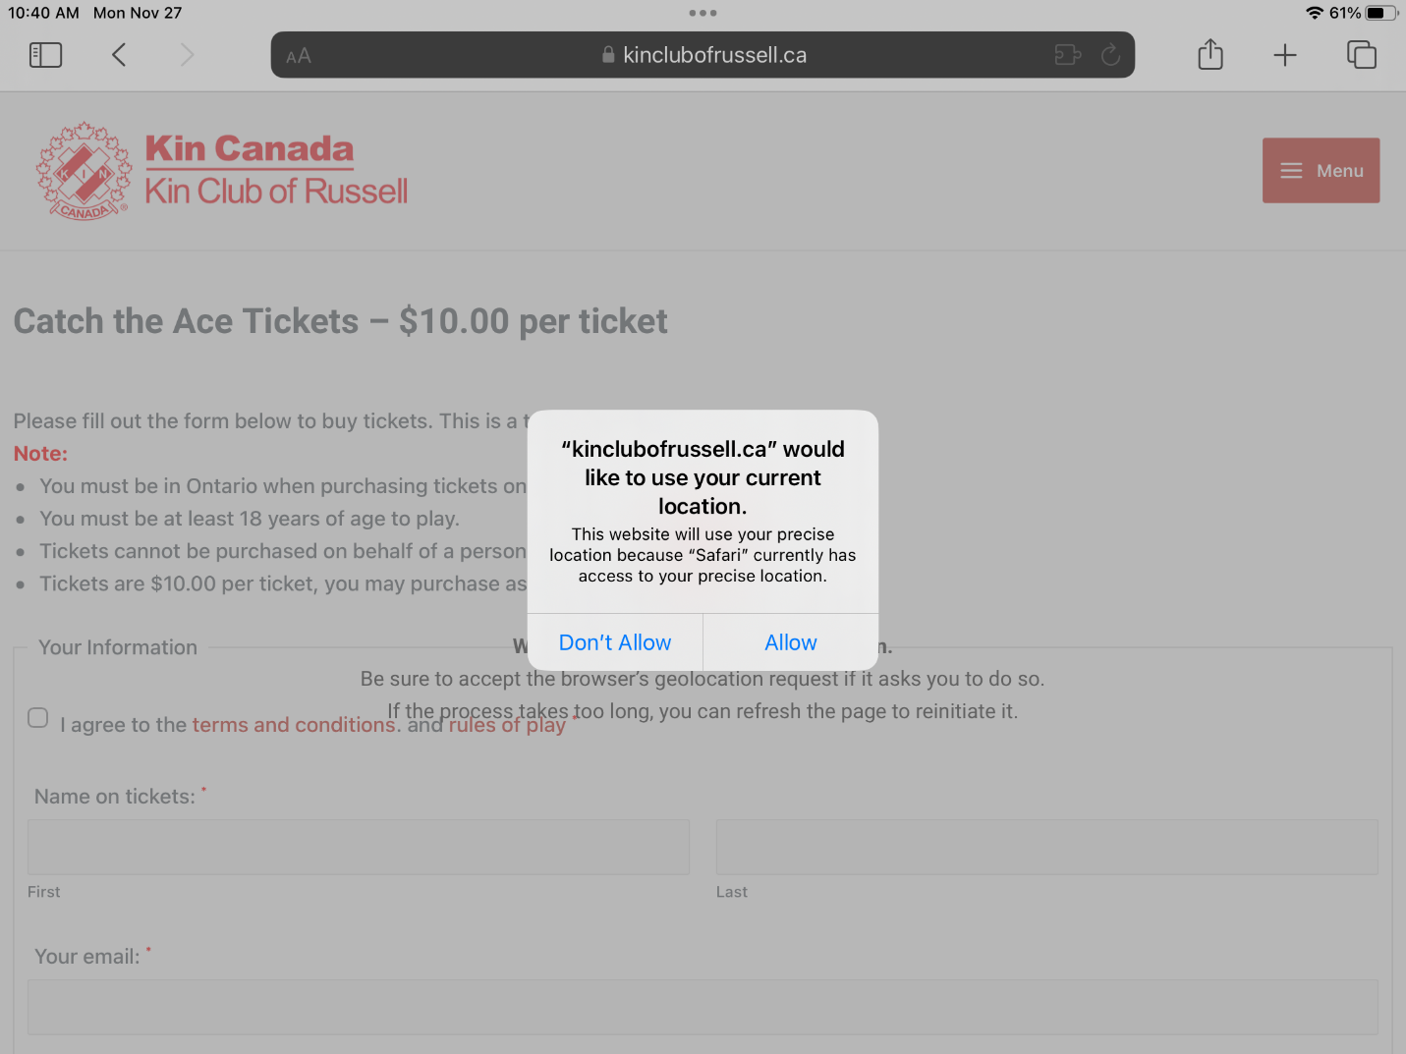

- If you see this screen below, it means your settings are blocking our site and you cannot purchase.
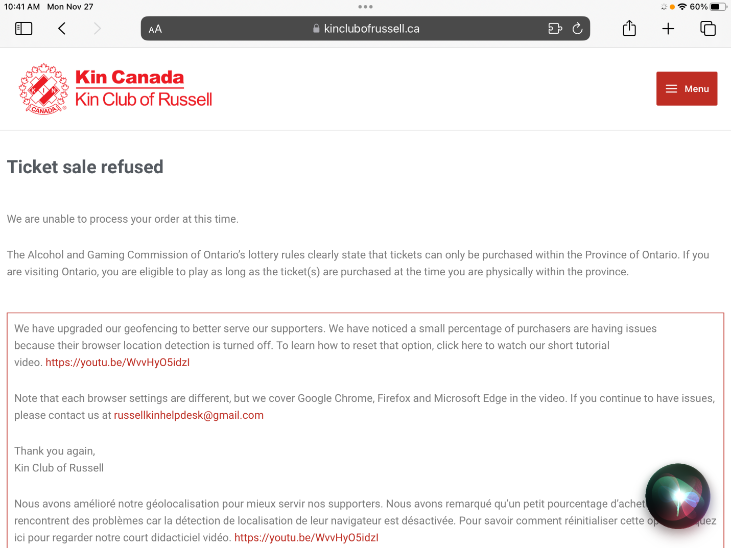

- Go to “Settings” on your tablet/iphone and open settings. Click on Safari as noted below.
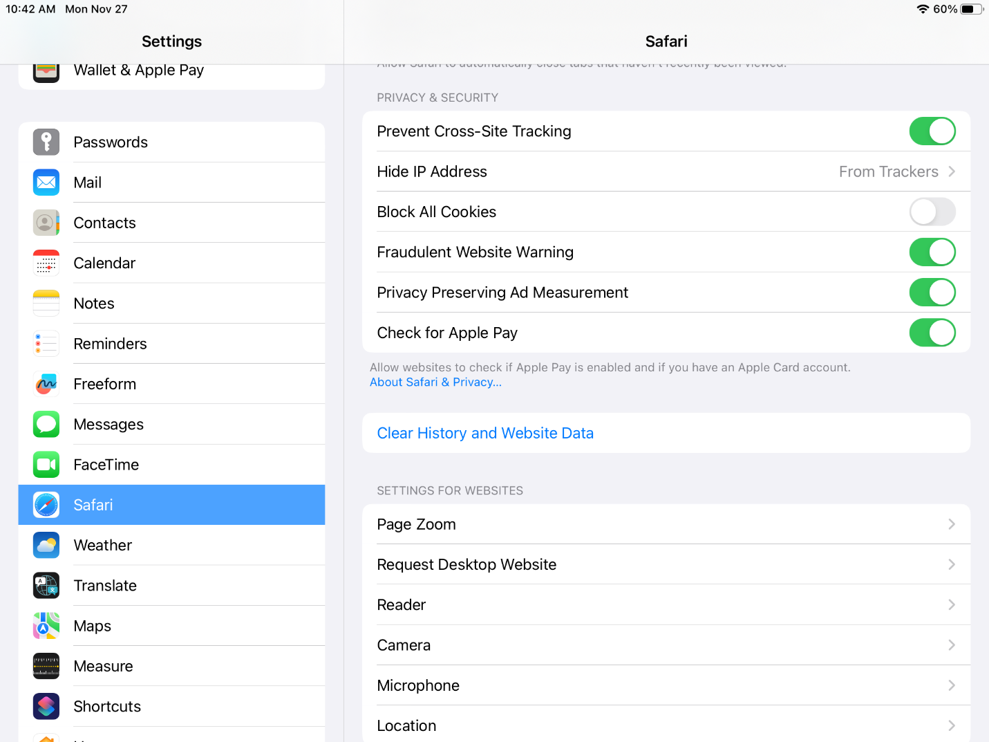

- Scroll down on the right side of the screen until you see the “Clear History and Website Data” as indicated above. Click on this tab.

- Click on the “Clear” button as indicated below. Then click on “Close Tabs” where the last “Clear” tab had been. The “Clear History and Website Data” will no longer be highlighted in blue.
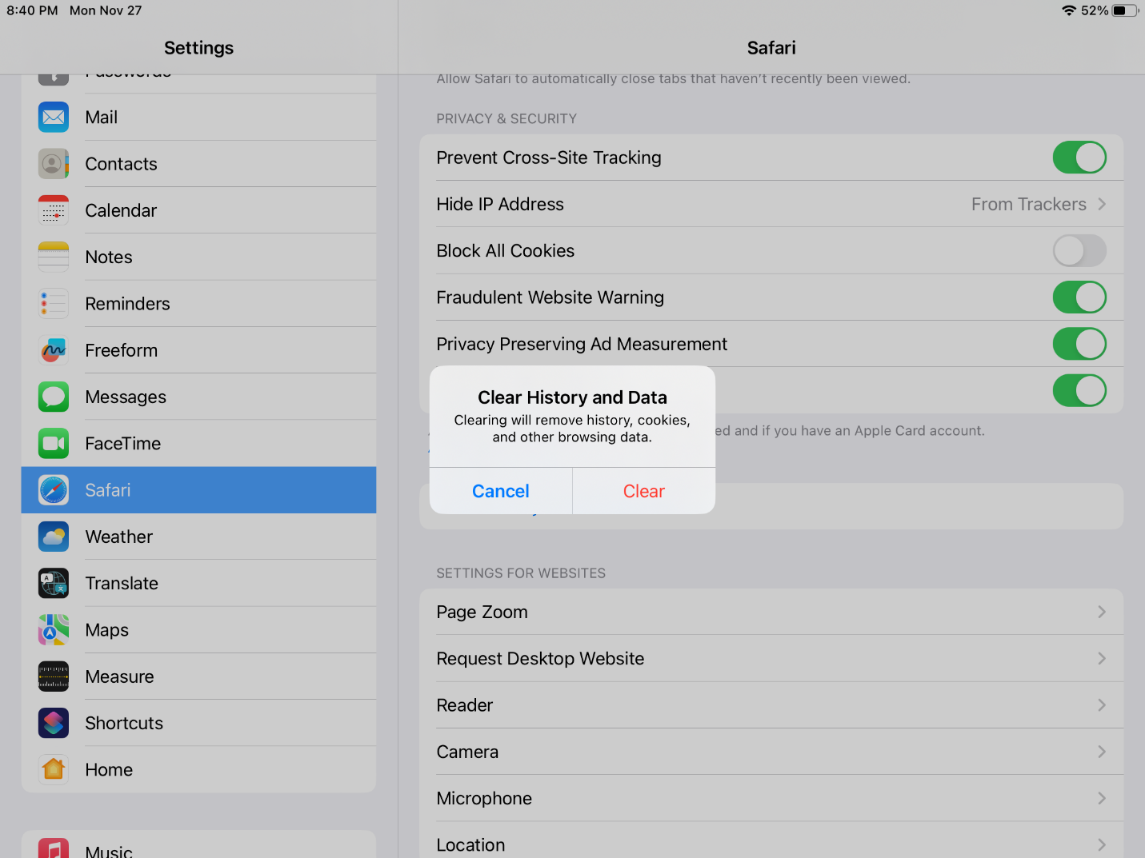

- The screen when you go to our site will now look as noted below. Make sure you click on “Allow” to proceed.

- If you are still having troubles, other options include trying a different device or different browser.
- Contact the russellkinhelpdesk@gmail.com with the Subject Line “Need Help” and your phone number. We will call you promptly to help you purchase tickets online.
Thank you for your support of our charities and your understanding.

Kin Club of Russell

