GOOGLE CHROME BROWSER LOCATION TROUBLESHOOTING FIX
The Kin Club of Russell is mandated by the Alcohol & Gaming Commission of Ontario (AGCO) as part of our Catch the Ace 6 lottery (RAF1341100), to utilize a location software to prevent anyone physically outside of the province of Ontario from purchasing online tickets.
The issue you may be having in trying to purchase tickets, is not with our system, but rather your personal browser settings blocking access to show its location. If your browser refuses to show its actual location, tickets sales will be refused as it cannot verify you are physically in the province. Please note this is your browser settings and not your general notification settings.
Please follow the following steps;
- If you are using a Virtual Private Network (VPN), please turn it off to purchase your tickets.
- Open the Kin Club of Russell’s Catch the Ace page on your device – www.kinclubofrussell.ca/catch-the-ace/
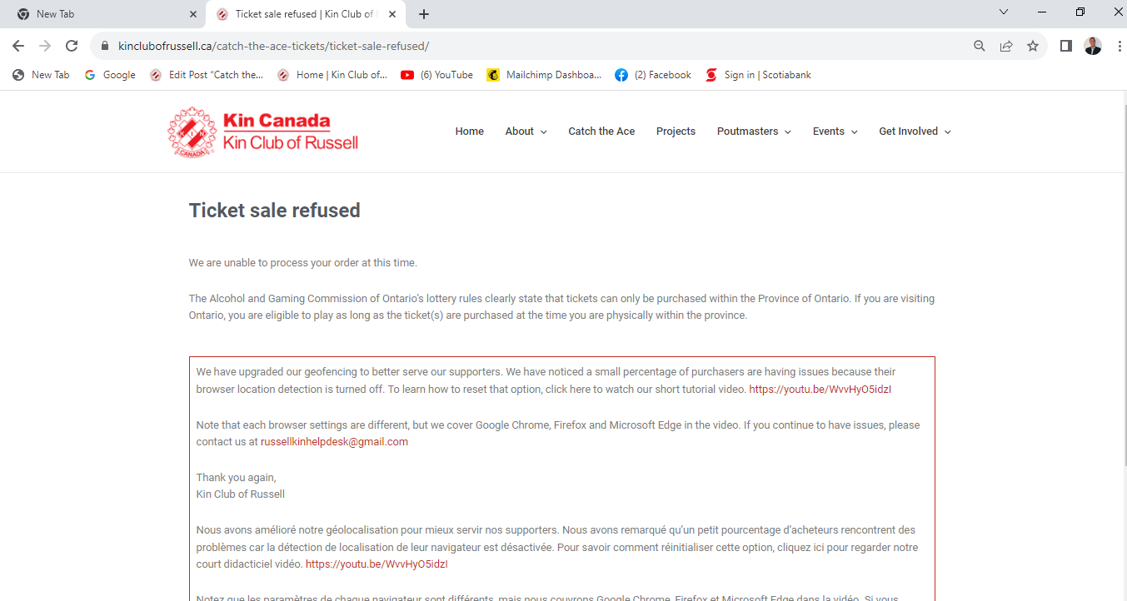

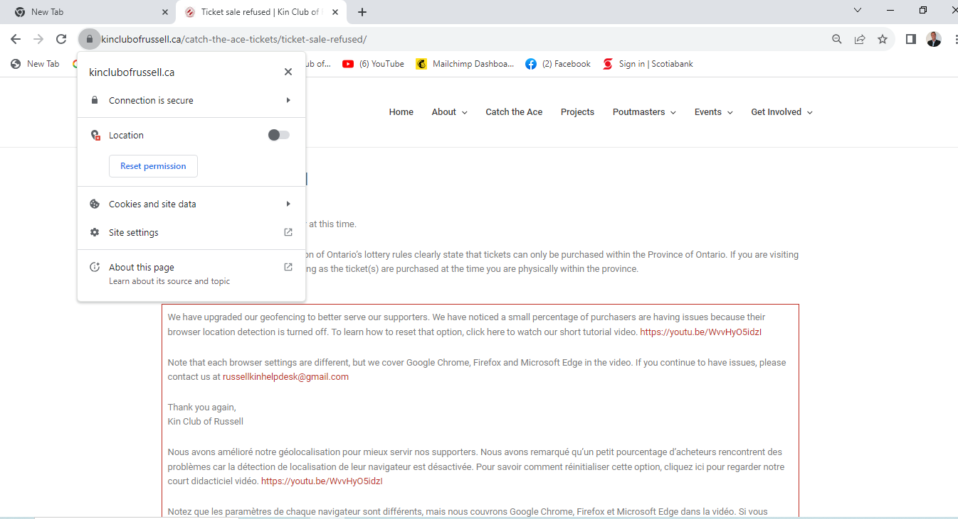
- Right click your mouse over this “lock” image to show its location settings.

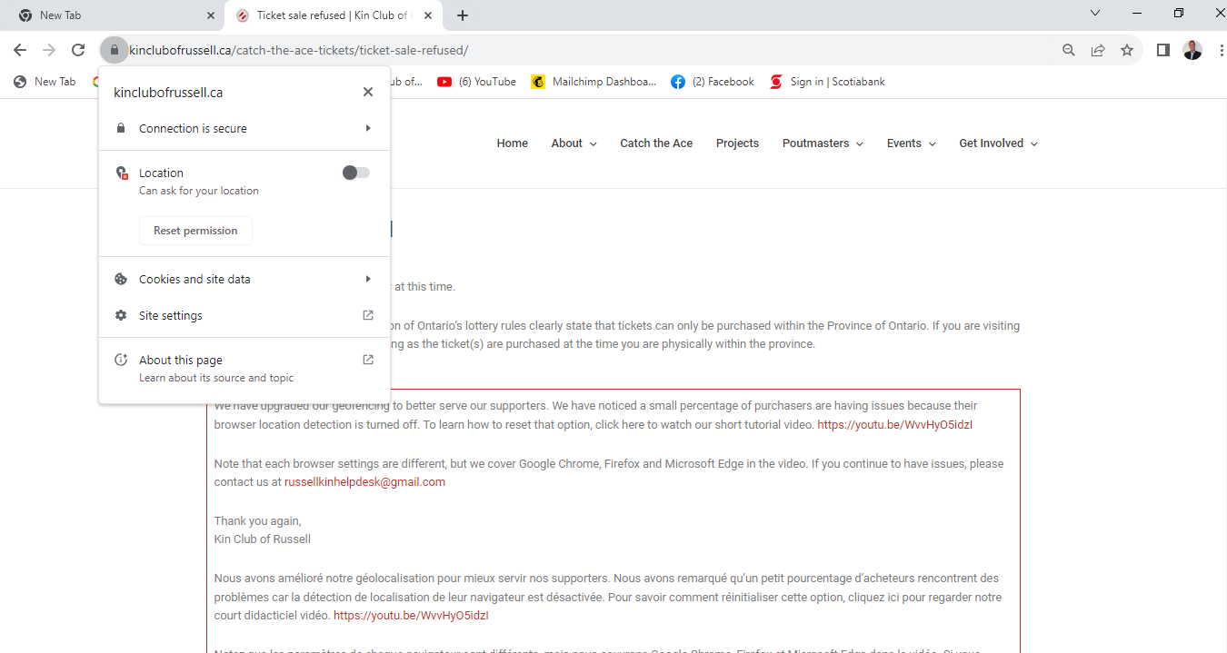
- Click on the Location tab to on as shown below to reset your permissions.

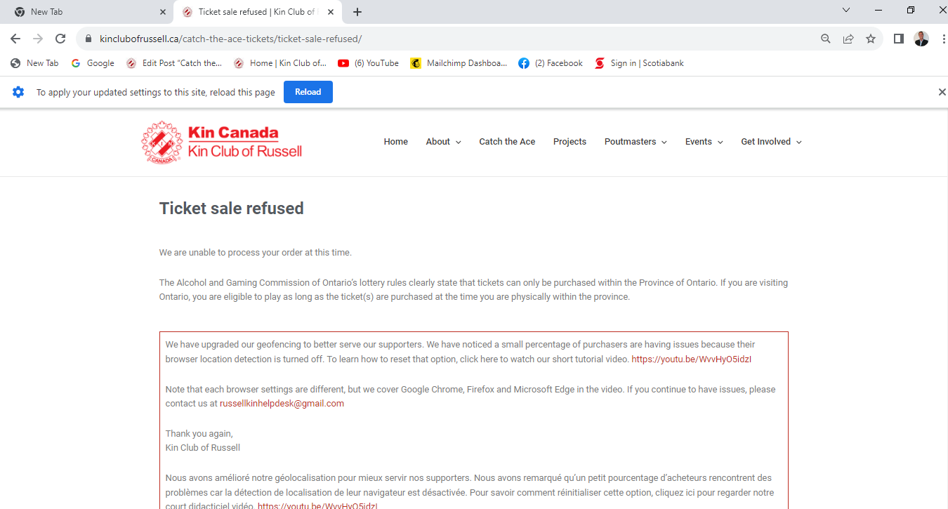
- Click on the “Refresh” page button to save your settings for the future.

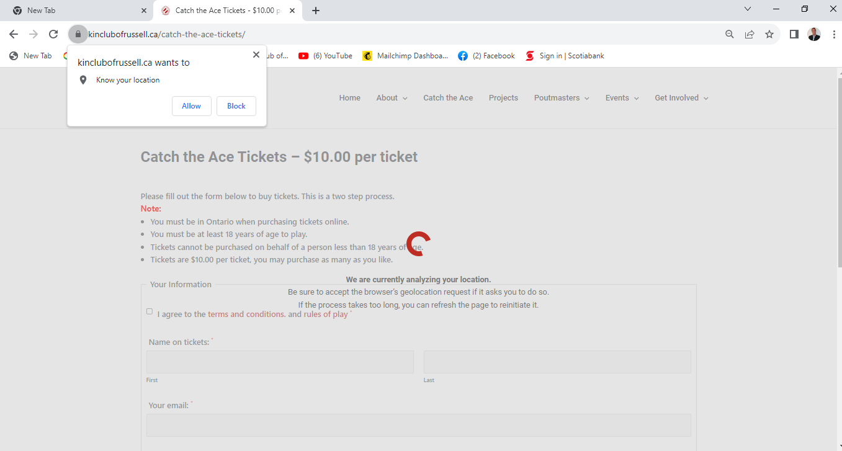
- Close your page and re-open it www.kinclubofrussell.ca/catch-the-ace/. Click “Allow” to show your location.

- You should be able to purchase your tickets.
- If you are still having troubles, other options include trying a different device or different browser.
- Contact the russellkinhelpdesk@gmail.com with the Subject Line “Need Help” and your phone number. We will call you promptly to help you purchase tickets online.
Thank you for your support of our charities and your understanding.

Kin Club of Russell

